# Understand API PolicIES

1. In the Publisher Portal, go to Policies to view the various API policies that can be configured and is already configured.

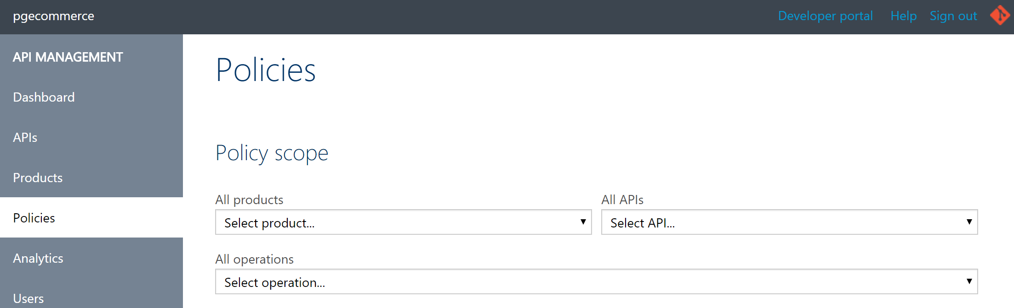

1. Look at the different scope levels at which a policy can be defined.
   1. Global level
   2. Product level
   3. API level
   4. Operation level

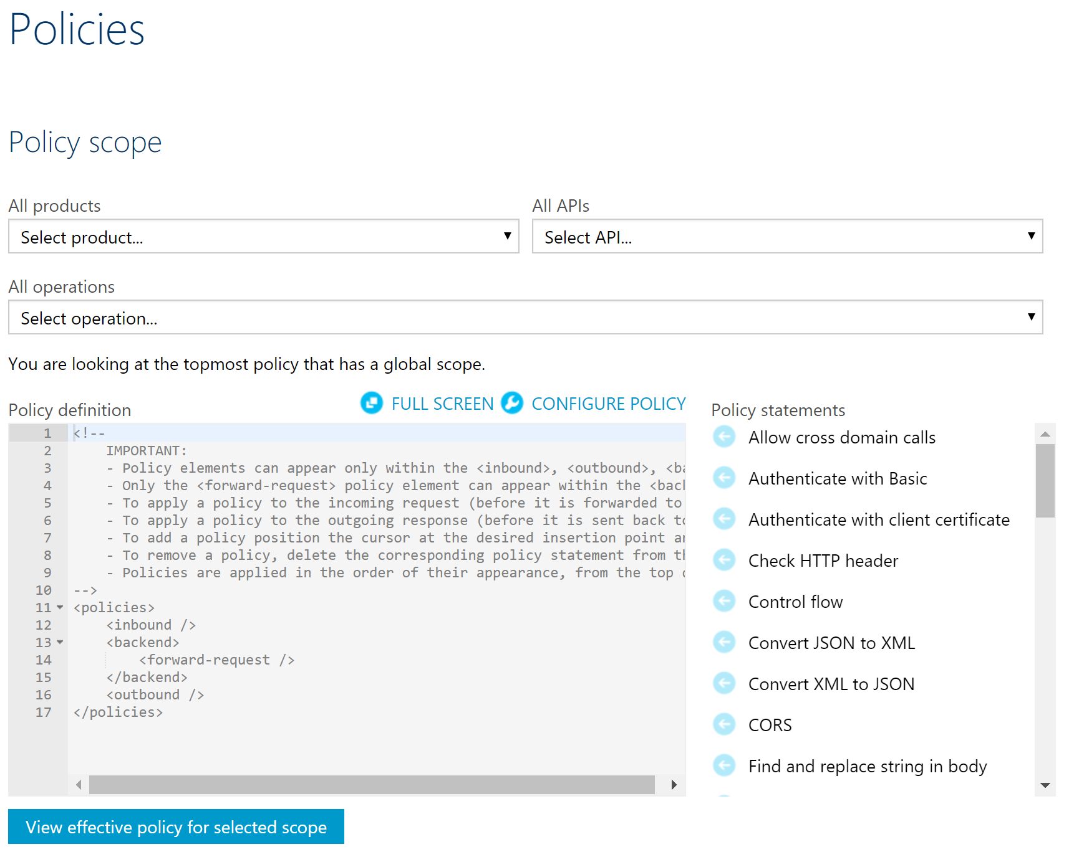

1. Understand the 3 key areas of an API request lifecycle where policies can be configured – inbound, backend and outbound.
2. Look at the various policy options available in Azure API Management – authentication, access restrictions, data transformation, caching and so on.

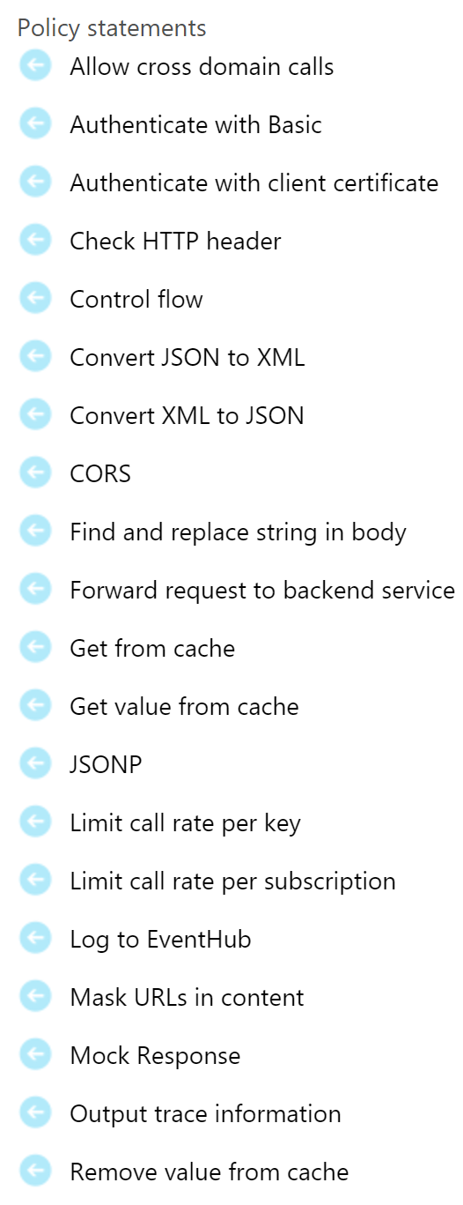

# References

* Policy reference – <https://docs.microsoft.com/en-us/azure/api-management/api-management-policy-reference>
* Policy expressions – <https://docs.microsoft.com/en-us/azure/api-management/api-management-policy-expressions>